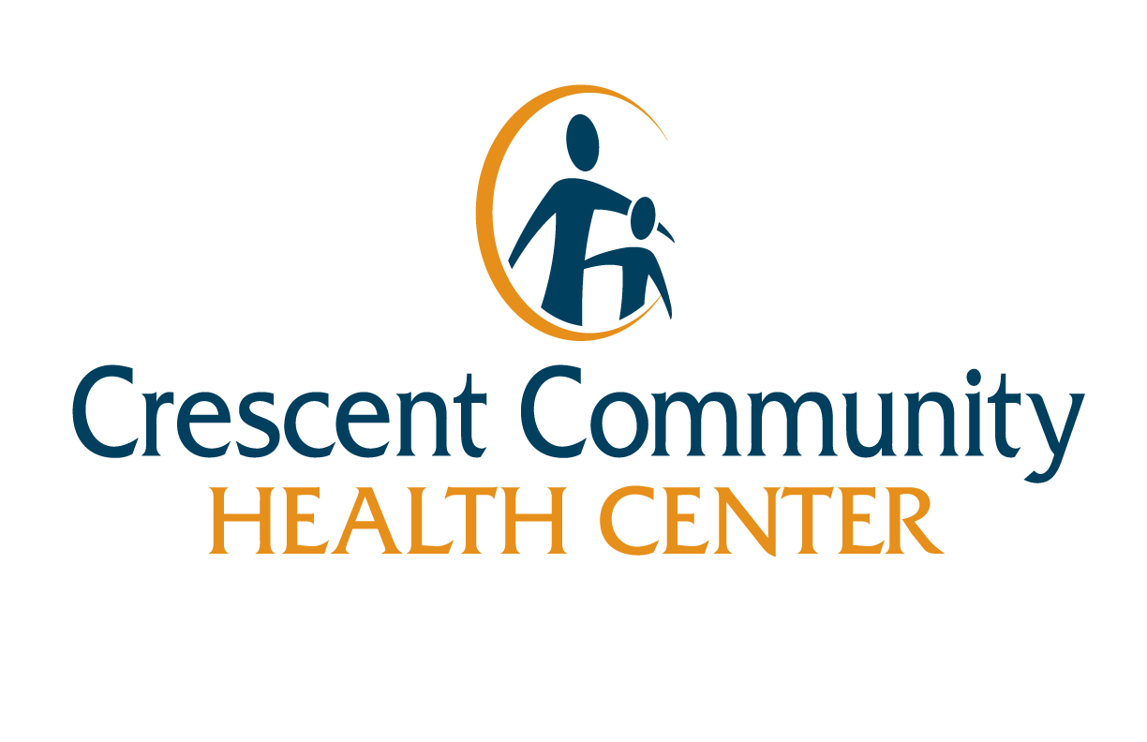
Healthcare Related Student application

1789 Elm Street Suite A
Dubuque, Iowa 52001

We’re excited to have you join us! Please complete this form and sign below.

Contact Becky for any questions regarding student opportunities at (563) 690-2858 or rwunderlin@crescentchc.org.
Applicant Information
Name:
Phone: |  |  |  |  |  |  | Alternate Phone:
Email address:
Current address:
City: |  |  |  | State: |  |  |  |  | ZIP Code:
Mailing address (if different than your current address):
City: |  |  |  | State: |  |  |  |  | ZIP Code:
List the language(s) you speak, read and/or write:

Emergency contact (name and number):
Health restrictions (please list i.e., asthma, bad back…):
Do you have a valid I.D? Yes No |  |  |  |  |  | Do you have reliable transportation? Yes No
SCHOOL Informaiton
Name of school you currently are attending:
Anticipated graduation date: |  |  |  |  |  |  | Semesters completed:
Address: |  |  |  |  |  |  |  |  | How long?:
Phone: |  |  | City: |  |  |  |  |  | State:
ZIP Code: |  |  | Clinical Instructor:
Previous Clinical Rotations/Internships
Organization/Preceptor: |  | Position/Major responsibility: |  |  |  |  |  |  | Dates of rotation (month/year)  From: To:
REFERENCES
Please provide a name, number and email address for each:

Availability
 | Monday | Tuesday |  |  | Wednesday |  |  | Thursday | Friday | Saturday
From:
To:
How many hours do you need to fulfill this rotation? (please circle) 1-5 6-10 11-15 16-20
list skills, interests, and training
Skills:

Interests:

Training:

To place you in the most rewarding student experience, indicate the areas listed that you would be interested in (Check all that apply):

- Family Medicine
- Community Health
- Women’s Health
- Pediatrics
- Geriatrics
- Other (please explain):____________________________________________________________________

What is your primary reason you want to be a student at Crescent Community Health Center?

Please provide us with any additional information about yourself you feel would be relevant to your selection:

How did you find out about our student opportunities?

I understand the information that I have provided will be kept confidential and available only to the Directors of the project that I am volunteering for and those designated by them for the selection and training of volunteers. This information was requested in order to determine your experience, availability, motivation and needs for volunteering.

I agree to sign a strict confidentiality statement and abide by it when participating as a Crescent Community Health Center Volunteer.

I agree to do my best to be a good representative of Crescent Community Health Center.

By signing below, I understand the above information and I certify that this application is true and complete to the best of my knowledge.

Signature: Date:

